# SAGE X3 BMS

# PROCESS MANUAL

***REF: BCL/QMS/BYS/SOP/USM/001***

**CATEGORY MANAGER**

* **How to Create a Purchase request.**

Navigate to Purchase-Purchase request

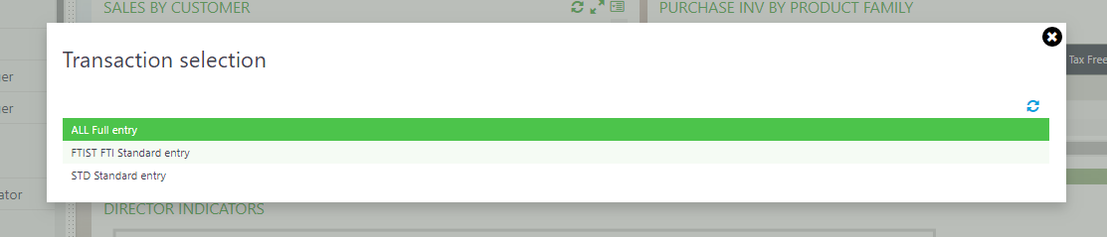

Select All full entry

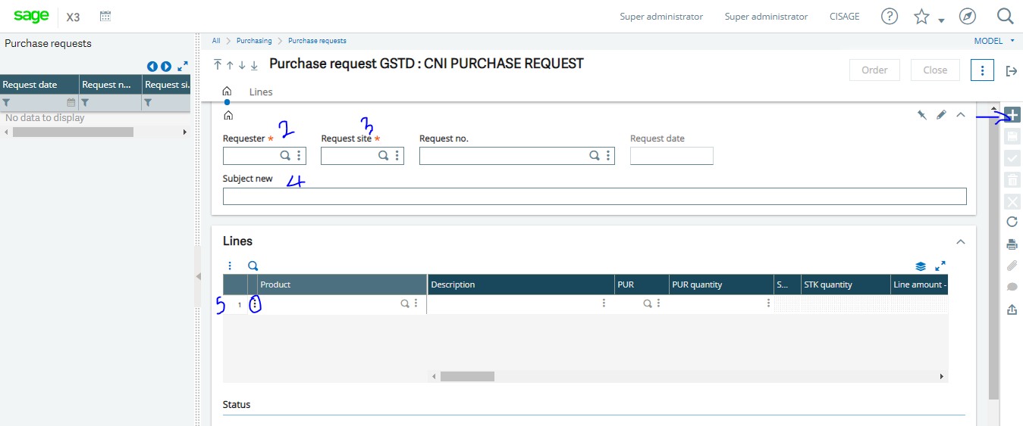

1. Click on New, the system automatically defaults the login profile as the requester
2. Tab through to enter the request date
3. Tab through to the lines, Use the search button to select the products.
4. Tab through to select the supplier that suppliers the product (Optional)
5. Tab through to the end to fill required information.
6. Once completed, click on Create.

This document will require approval from the appropriate person(s). To approve or disapprove this request.

Goto-Usage-Usage-Workflow monitor

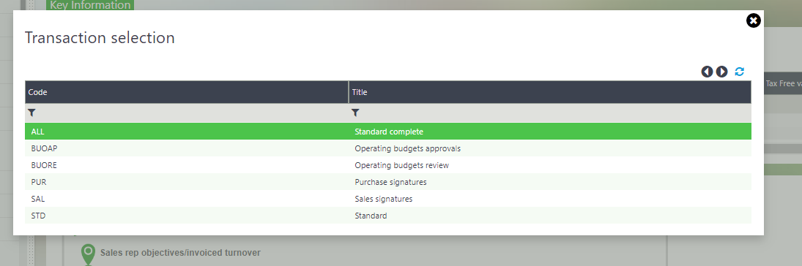

Select the module which you are approving documents from, In this case, it’s a Purchasing document, and therefore you will click on the Purchase Signatures

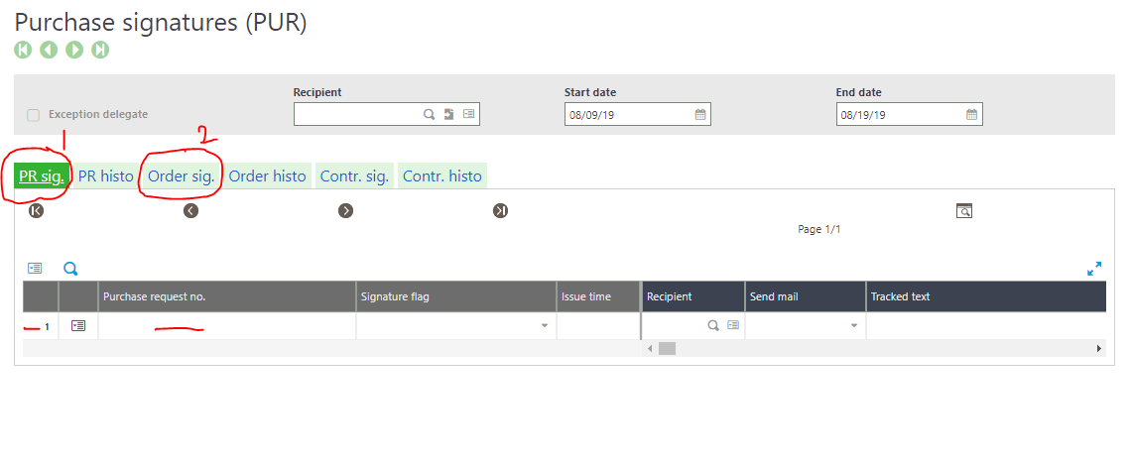

1. PR Sig means Purchase request signature and this means you can find pending Purchase request document awaiting approval here.
2. Order Sign means Purchase Order Signature, this means you can find pending Purchase Order documents awaiting approval here.

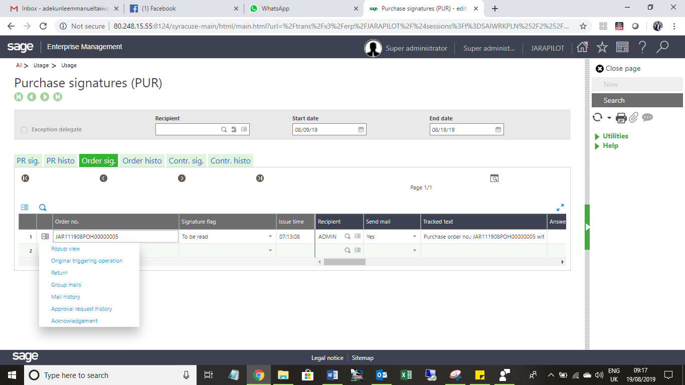

1. Click on the Action Button- Find and Select approval to Accept or Reject the document.

Note: The Approval process explained above is applicable to every document processed that requires approval in Sage X3.

Once the document is Approved, that ends the Purchase request process.

* **How to Raise a Quote Request**
* In sage X3, To convert a Purchase request to Quote Request

Go to – Purchasing – Quote Request.

Click **NEW** (+) & select the **SITE**, then scroll down to the left panel and Click on Purchase Request.

You will see list of PR raised for the particular site and Select the one you want to convert to quote request.

* Goto LINE and select the vendor you want to send the quote request too. If you have additional information you can add them also, then click create.

Fine screenshot below.

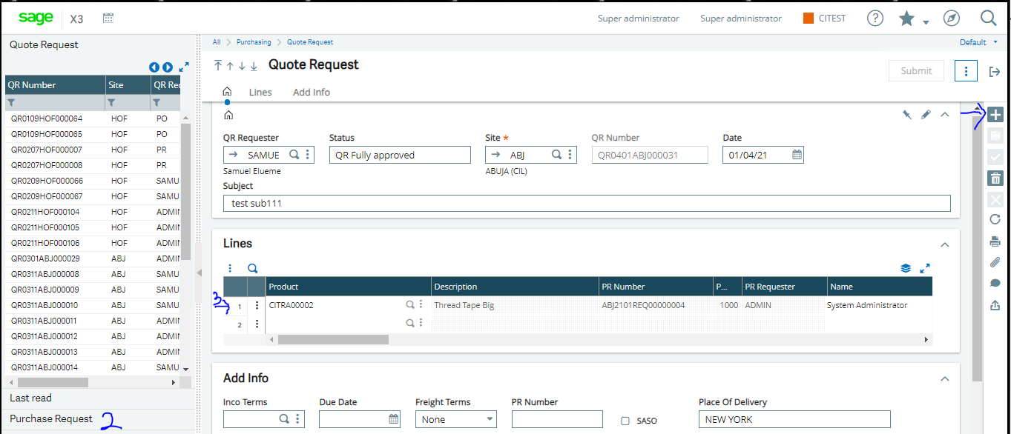

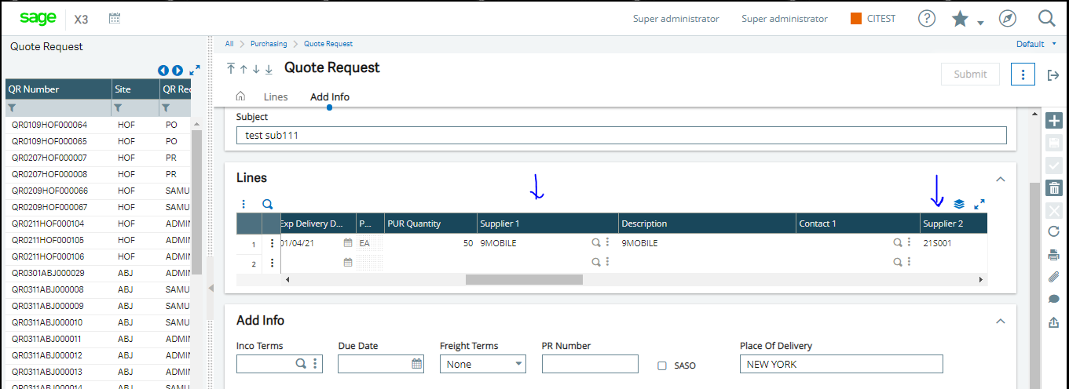

* **How to Raise a Quote Request Response**
* To create a Quote response, goto – purchasing – quote request response.

Move to your left panel and search for the Quote request number you want to capture the response.

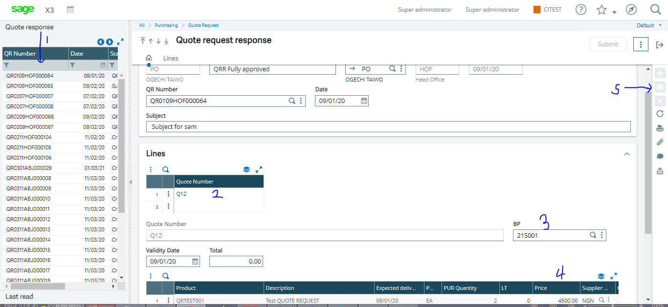

After select the quote request, it will display on the screen then input your quote number and select BP.

Scroll to the lines and add the amount (price) of the vendor.

* **How to Raise a Quote Selection**
* To create a Quote Selection, Goto – purchasing – quote Selection.

Move to your left panel and search for the Quote Request Response number you want to capture the response.

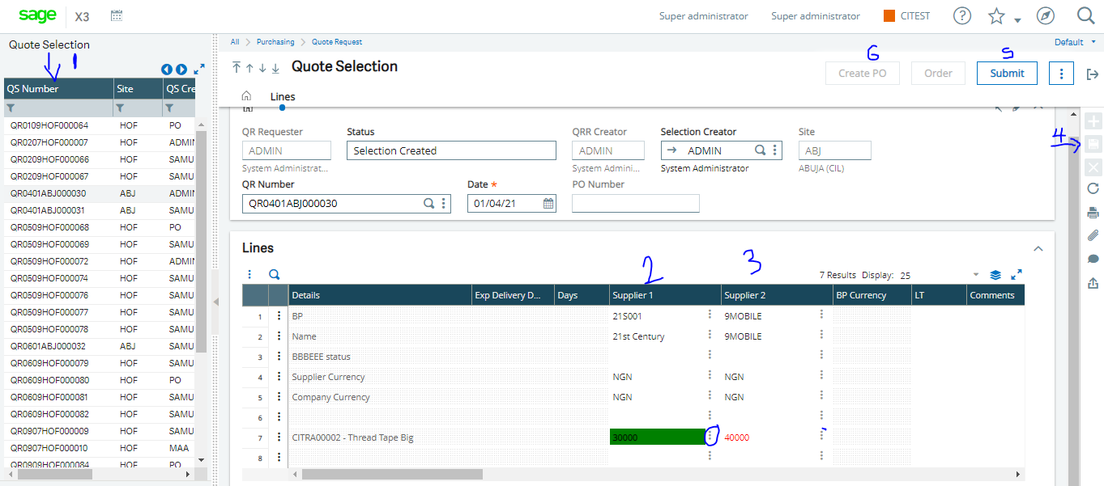

After selecting the quote request response, it will display on the screen then

Scroll down to the lines and select the BP and amount you prefer.

* **How to Raise a Purchase Order**

In sage X3, you can either convert a Purchase request to an Order or Raise a fresh Purchase Order independent of a prior Purchase request form raised.

Converting a Purchase request can easily be done by Clicking on Order on the Purchase request raise as shown below.

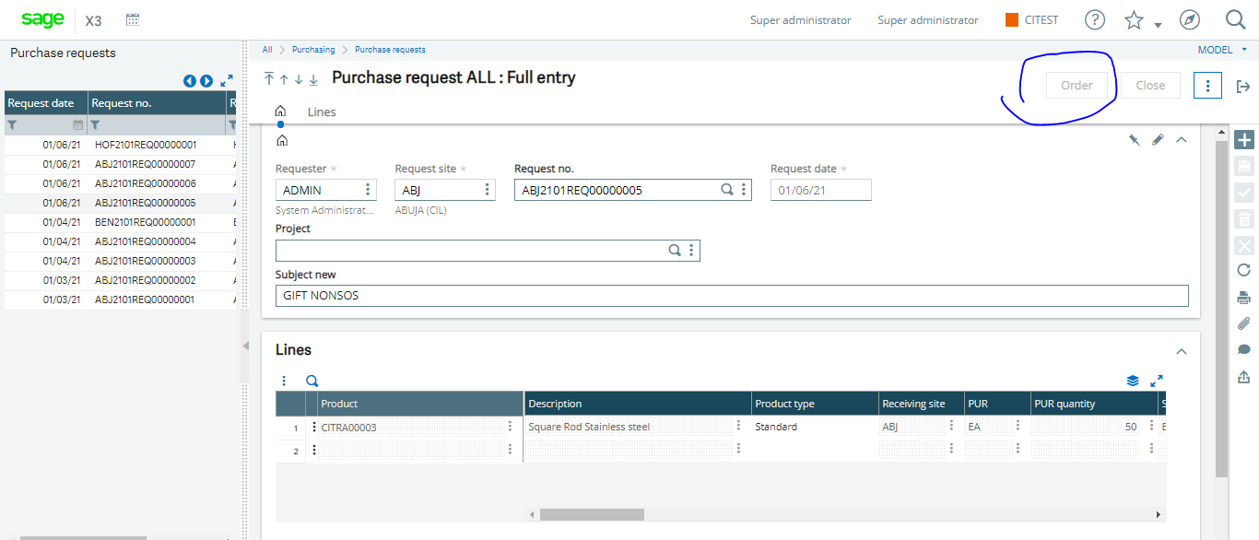

Otherwise Goto – Purchasing- Orders- Orders

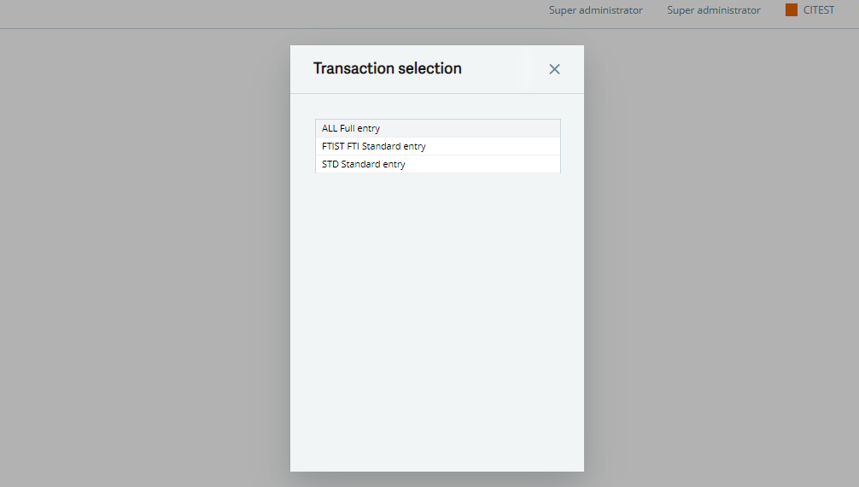

Select All full entry

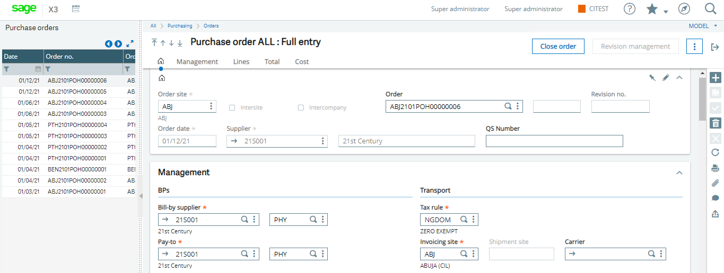

1. Click New
2. Select the Ordering site
3. Tab through the Order No., the system will default it automatically.
4. Select the Supplier you want to raise a LPO against

Navigate to the Lines Tab

1. To create a direct PO that is independent of a Purchase request, you can use the search button to select the product

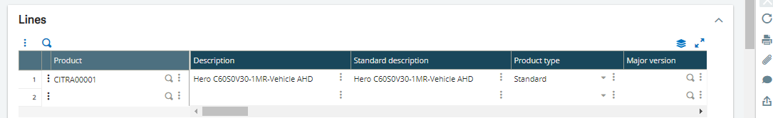

1. Tab through to fill in required information and Click Create once satisfied.

This document will need to be approved by appropriate person(s)

That ends the LPO process.

* **How to raise a Purchase receipt.(Goods Receive Note) – Note: this is optional as your Business process allows this to be done from Ivend**

Goto- Purchasing-Receipts-Receipts

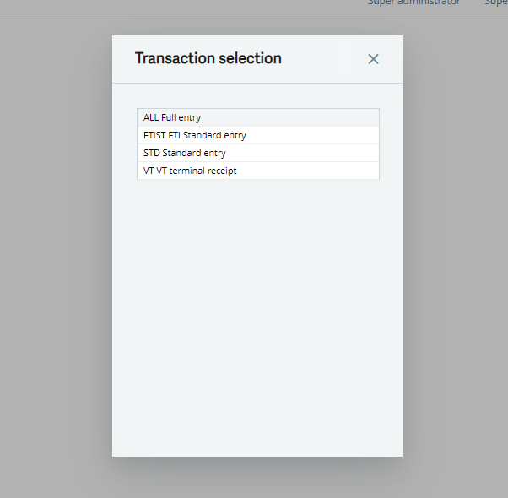

1. Select All Full entry

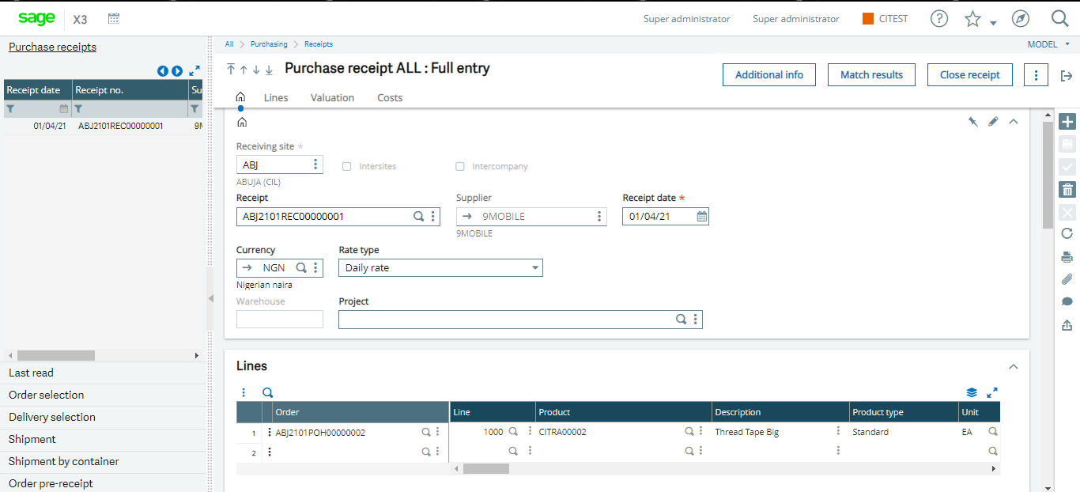

1. Click NEW
2. Select the Receiving Site
3. Tab through to the Supplier field to select the supplier from a drop down list

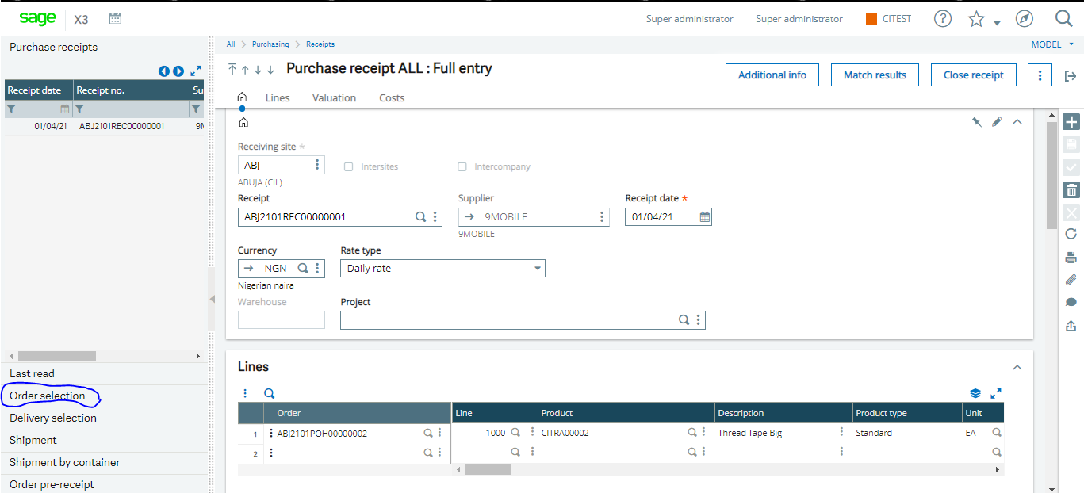

1. On the Left list panel, Click find and click on the Order selection. There will be a drop down list of LPO(s) to be fulfilled by the supplier. Select the applicable PO to process
2. Immediately you select the PO, the system populate the Lines with the details of the LPO, you are at liberty to scroll through to make changes if any. Example, if the LPO states 100 quantities and the Supplier has only delivered 98 quantities, you can make this changes on the line so that the system automatically calculates the liability to the supplier.
3. When all this is done and satisfied. Click on create.

That ends GRN process

* **How to Process Purchase Returns**

Goto Purchasing- Returns-Purchase Returns

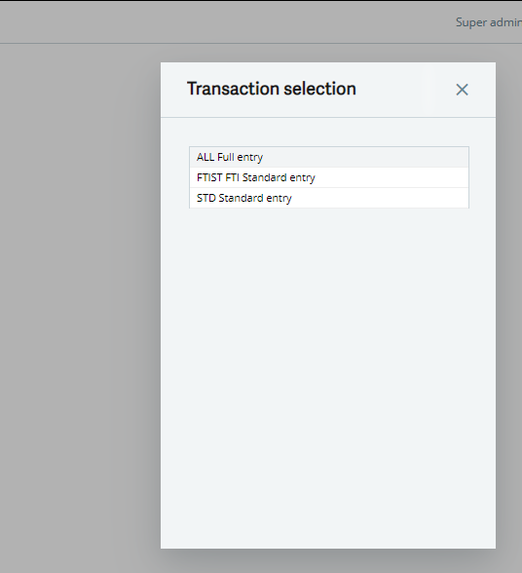

1. Select All Full Entry

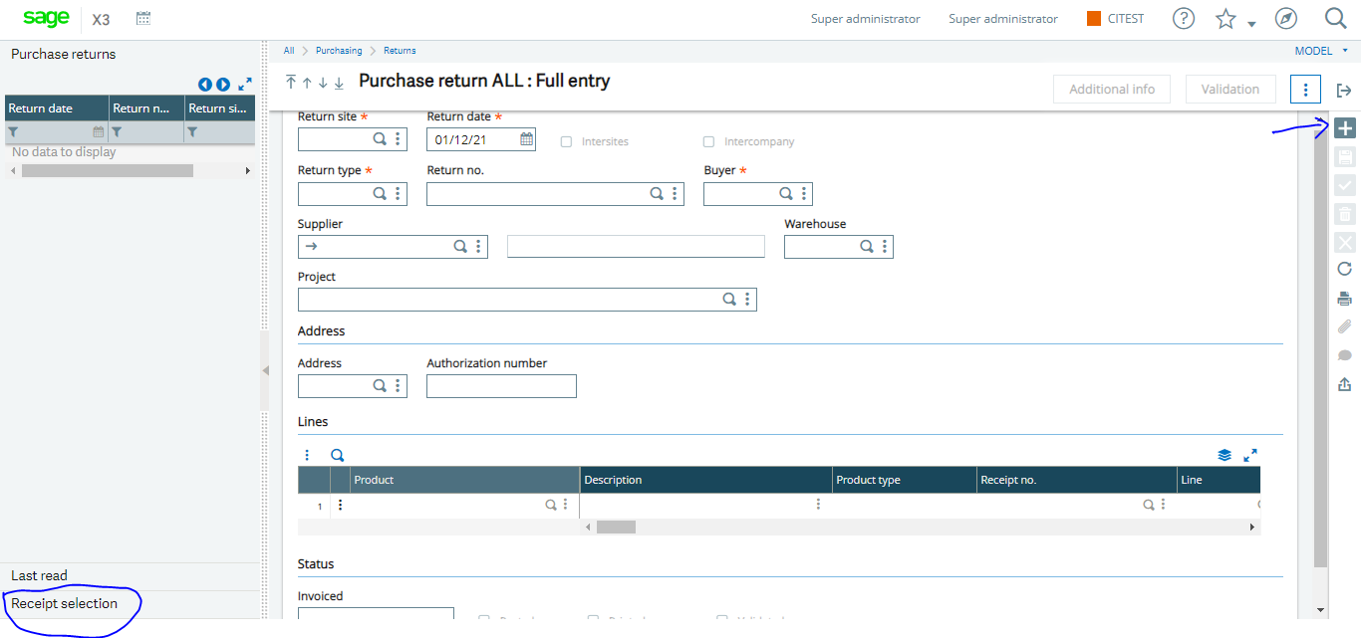

1. Click NEW
2. Select the return site
3. Tab through to the Supplier
4. Once you have selected the supplier, Go to you left list panel to select the Receipt selection(GRN) that was used to bring in the stock
5. Goto the line to select the Quantities that you want to remove and you may also use the Action button to delete the lines you are not returning
6. Tab through all fields to ensure you give the right information.

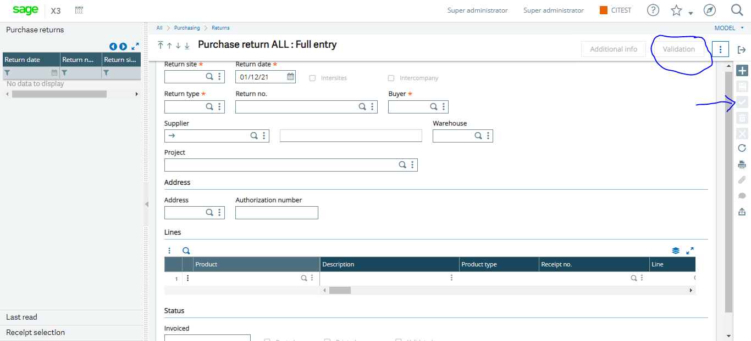

1. Click on Create and Validation
2. The system generates a Credit Memo against the Supplier for this Return Process.

That ends the Return Process

**ACCOUNTS**

* **How to Create Supplier Invoice and Credit Memo**

To create Purchase invoice, Goto-Purchasing-Invoice-invoice



1. Select All full entry

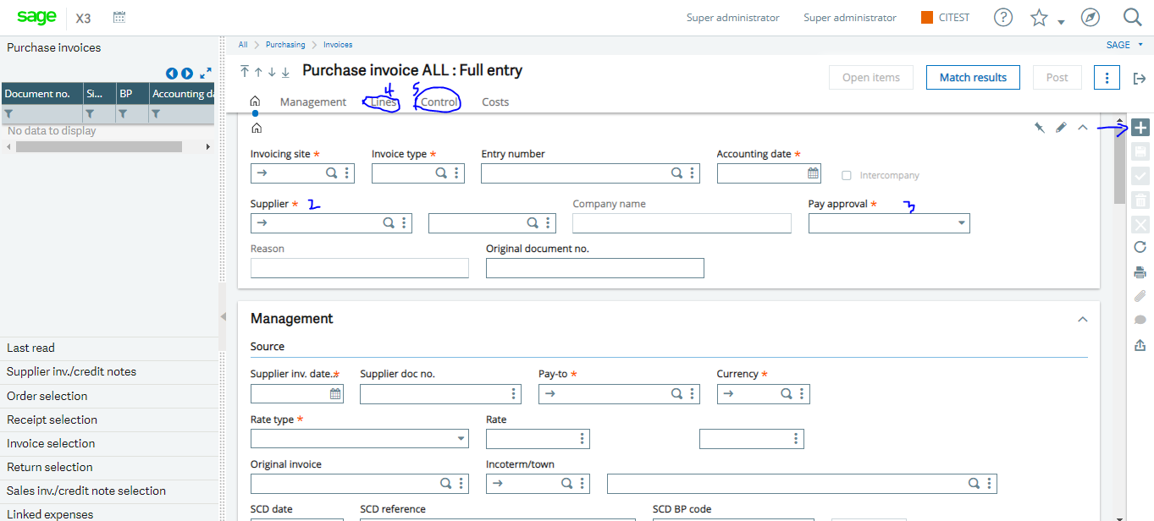

1. Click New
2. Select ZAINV as the Invoice type
3. Select the Supplier
4. Change the Pay Approval to Authorize to Pay
5. Type in a reference in the Supplier Document No. E.g the physical Supplier invoice no. from the supplier

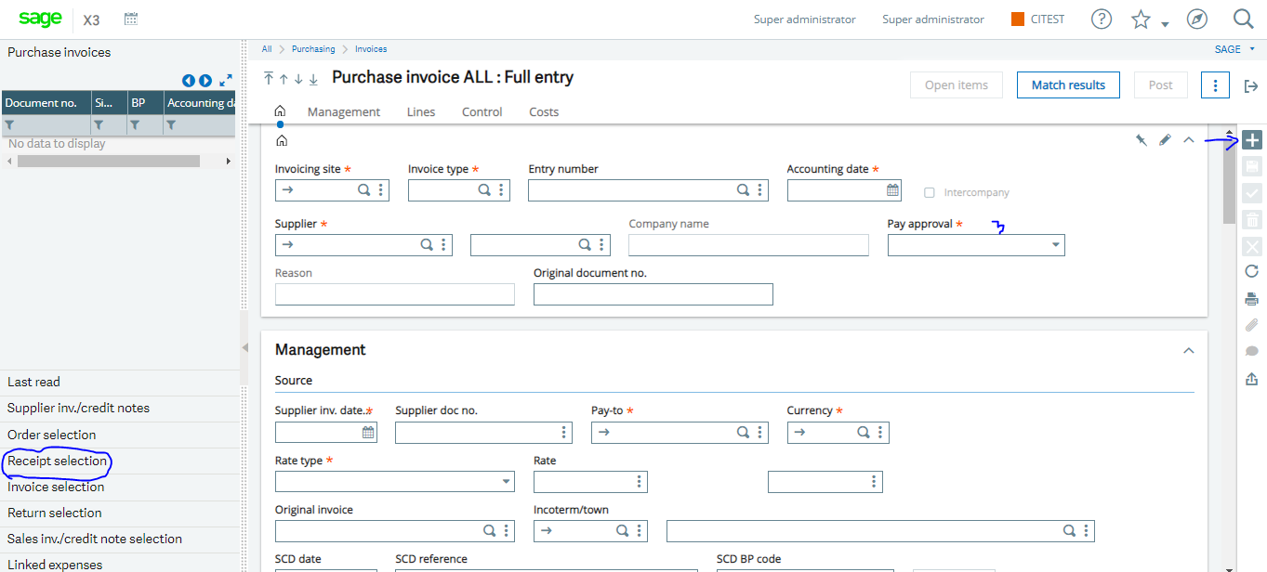

1. On the left list panel, find and select Receipt Selection, the system drops down the GRN pending to be invoiced to the Supplier according to what you have received
2. Navigate to the Lines Tab to confirm that the amount received is the amount to be invoiced to the supplier
3. Navigate to Controls

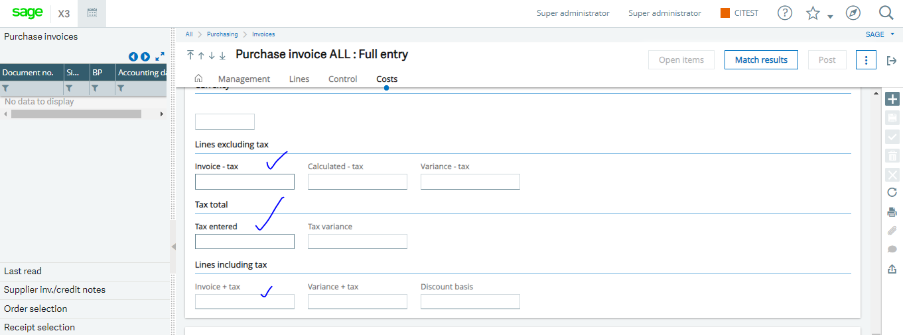

1. Copy the value in Tax Variance to Tax entered field and the Value-Tax to the Calculated-Tax.
2. Click Create and Post

That ends the Purchase invoice process.

* **To create a Credit note against a Supplier.**

Goto-Purchasing-Invoice-Invoice

1. Click New

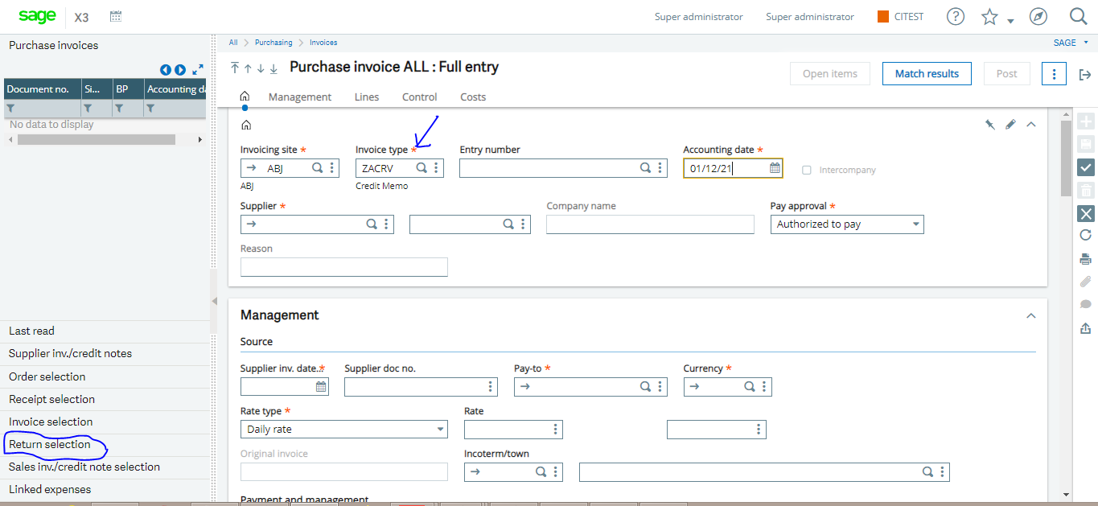

1. Select the Invoicing Site
2. Select ZACRN as the Invoice type
3. Select the Supplier
4. On the left list panel, find and select Return Selection to reference the Return document processed earlier on
5. Select the Return document from the drop down
6. Navigate to lines to confirm the amount to raise credit note for
7. Navigate to Controls



1. Copy the value in Tax Variance to Tax entered field and the Value-Tax to the Calculated-Tax.
2. Click Create and Post

That ends the Credit Memo process.

* **How to make Payment to Supplier**

Goto-AP/AR Accounting-Payment-Payment/receipt entry

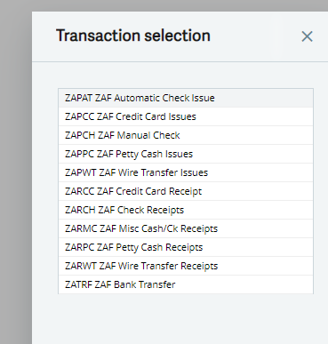

1. Select the Mode of Payment

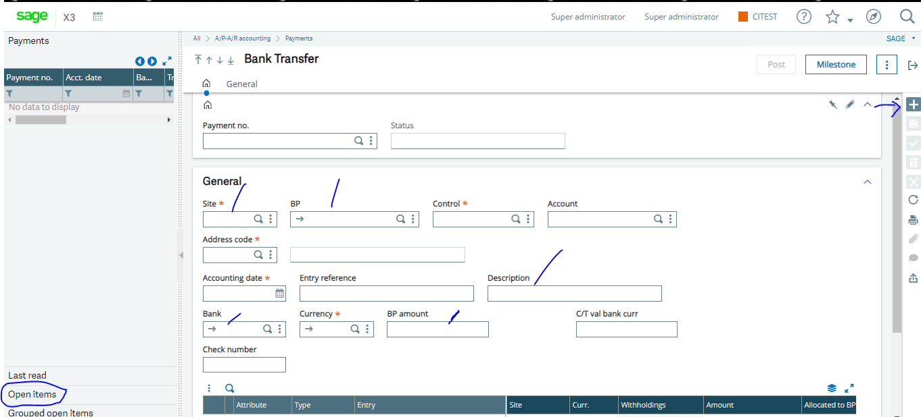

1. Click New
2. Select the Site
3. Select the Supplier in the BP field
4. Enter a Reference description for tis payment to ease reconciliation
5. Enter a Description for this payment to ease reconciliation
6. Select the Bank you wish to make the payment
7. Use the BP amount to enter the Amount you are paying to the Supplier but the Sytem will automatically calculate this if you have selected open items on the left list panel as shown below



Once satisfied with the entries

1. Click on Create and Post.

That ends the Payment Process and that also ends the Procurement to Payment process.

* **How to Run Account Interface.**

The Account Interface should be Ran after every stock movement either by GRN, Misc Issues or Receipt.

To Run Account Interface, Goto- Stock- Periodic Process

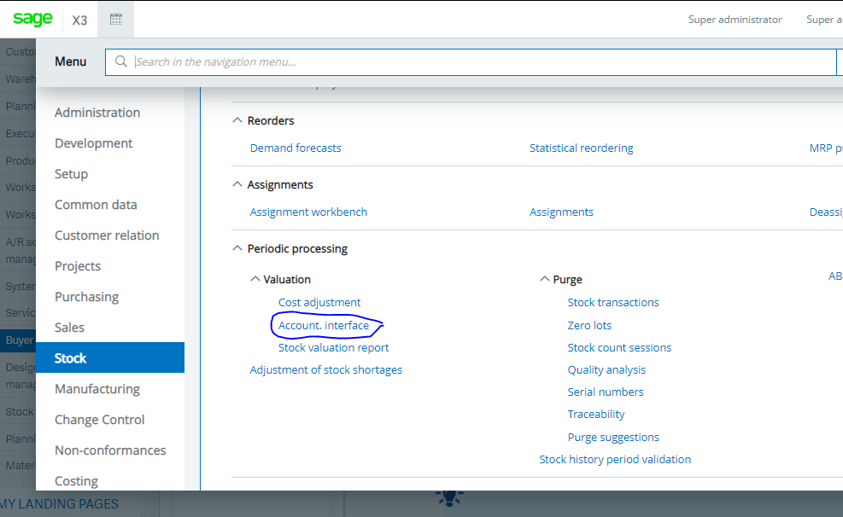

1. Select Account Interface

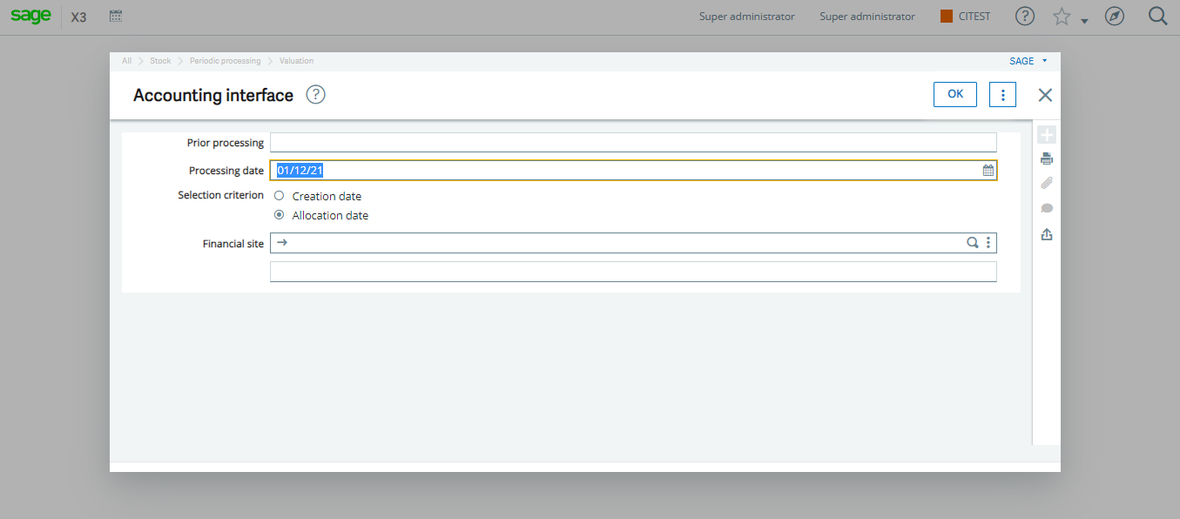

1. Click OK

The system generates a stock movement journal and that ends the Account Interface Process.

* **How to create Journal entries.**

Goto– Financials – Journals – Journal entries

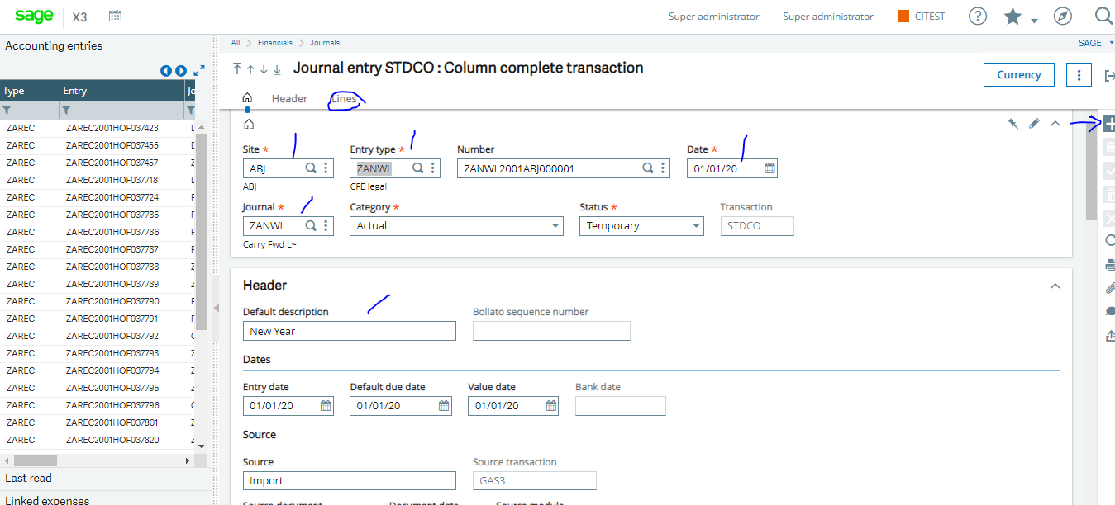

1. Enter the site
2. Enter the entry type which is usually ZAGEN
3. The system will automatically generate a reference number in the Number field
4. Enter a decent description

Navigate to the lines Tab

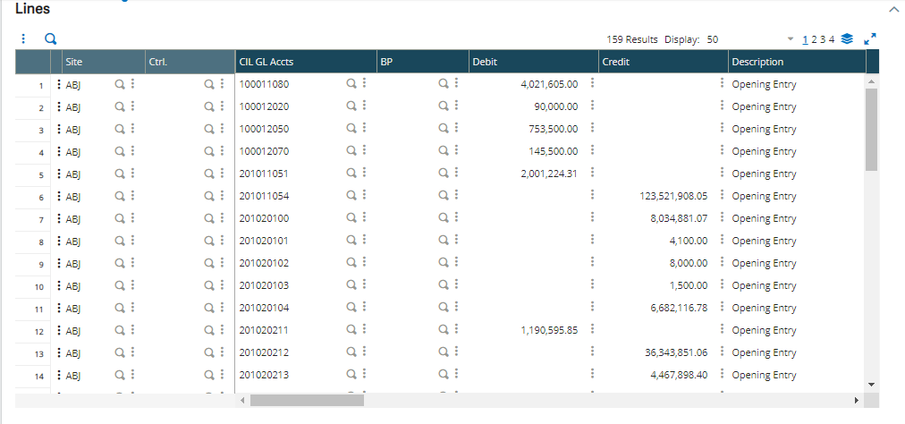

1. On the EDLP COA colum, select the account to be debited or credited, Tab to the Debit/Credit column to enter the value
2. Jump to the second line to enter the corresponding accounting to be debited/credited, tab to enter the value.

Note: The debit and credit value must be equal

* **How to Run and View reports**

There are various types of default reports in sage X3 added to the customised ones we have imputed in the system. To run reports in Sage X3 Goto reports –Reports

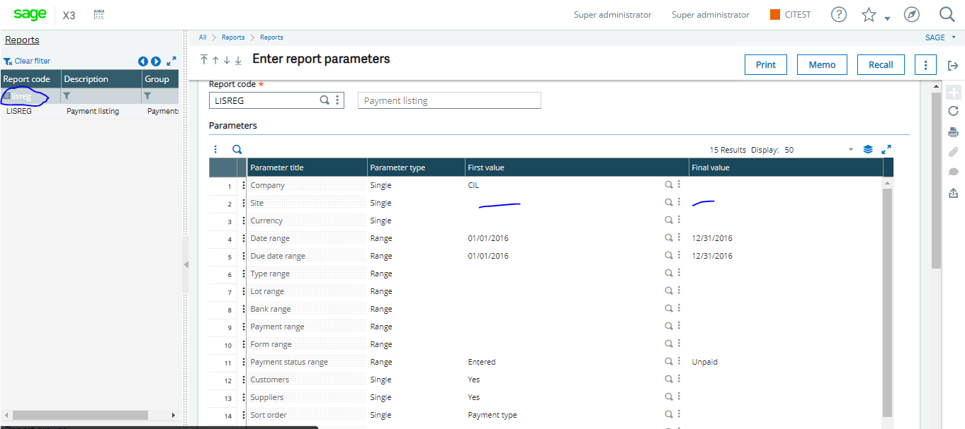

1. In the description field highlighted above, type the report name and click on print.
2. Select range if required for this report but leave blank if not required
3. In the destination field, select the format you wish to have your report which could be Excel or PDF
4. Click on print.

* **How to create Intersite Transfers**

Goto- Stock- Receipt/Issue transactions-Intersite transfers

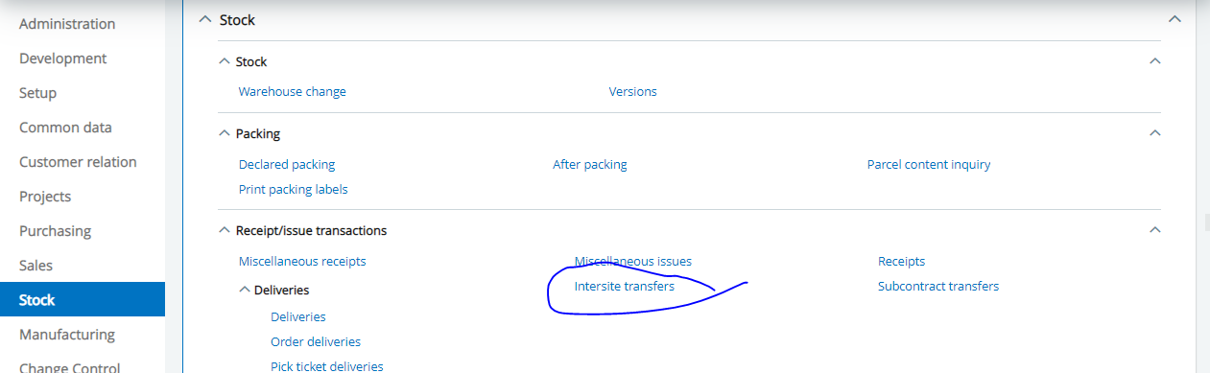

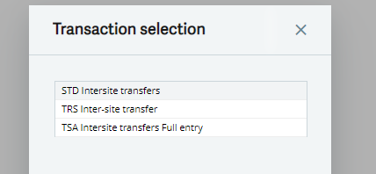

1. Select STD Intersite Transfers

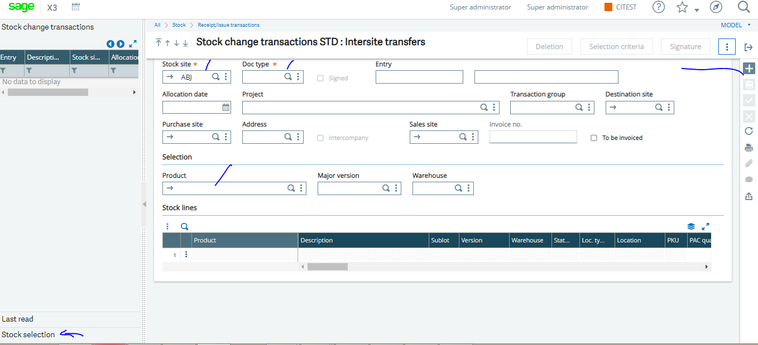

1. Click New
2. Select the Site you are transferring from
3. Select SCI as the document type
4. Select the Destination site you are transferring to
5. Scroll down to select the product you want to transfer
6. On your left list panel, click on the Stock Selection to drop down the Product and its Batch details and quantity.
7. Select the Batch from the list(If defined)



1. Scroll/Tab to STK Quantity to type in the quantity you wish to transfer.
2. Once satisfied with the information provided, Click Create
3. Run Account Interface as shown above

That ends the Intersite transfers process.

* **How to Create Miscellaneous Issues (WRITE OFF)**

Goto- Stock- Receipt/Issue Transaction-Miscellaneous Issues

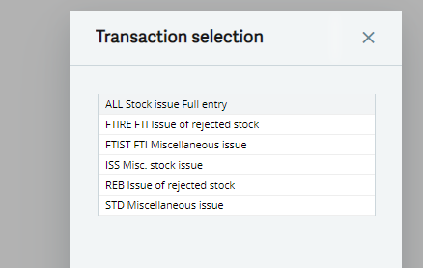

1. Select All stock Issue full entry

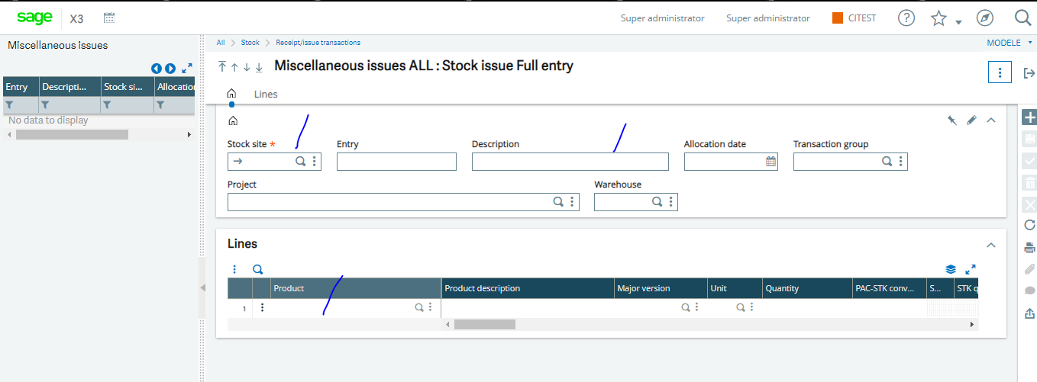

1. Click New
2. Select the Stock site
3. Enter a Description
4. Use the search button to select the Product you want to issue out of stock
5. Tab through to select the quantity you wish to issue out
6. Click Create
7. Run Account Interface

That’s the end of Misc. Issues

* **How to Create Miscellaneous Receipt**

Goto- Stock- Receipt/Issue Transaction-Miscellaneous Receipt

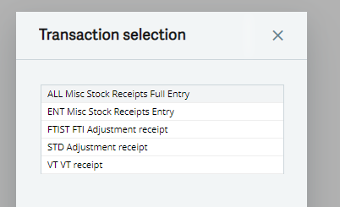

1. Select All Misc. Stock Receipt Full Entry

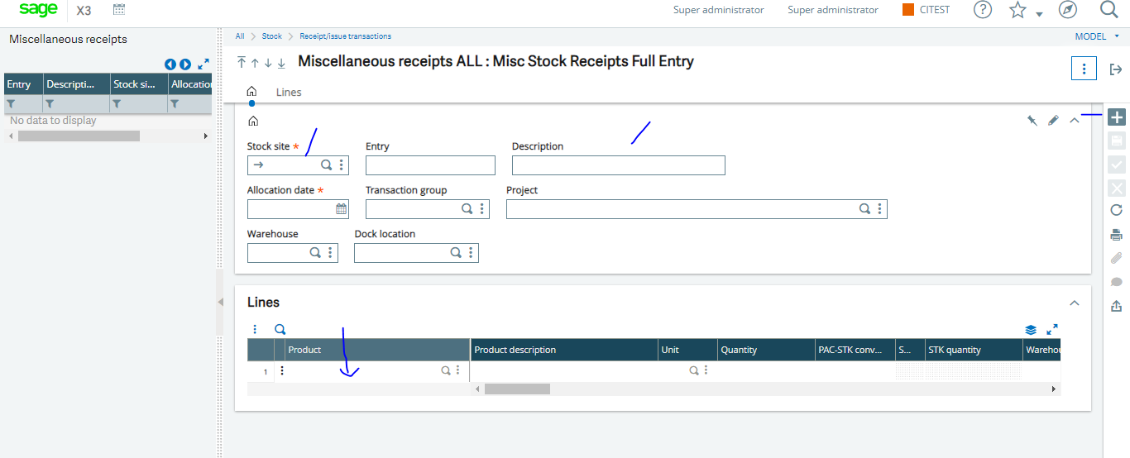

1. Click New
2. Select the Stock Site
3. Enter a description
4. Goto to the Line to select the Product(s) you wish to bring into your store.
5. Tab through to type in the Quantity
6. Click Create
7. Run Account Interface

That’s the end of Misc. Receipt

**MASTER DATA PROCESSING OFFICER**

* **How to Create Product**

Goto- common data-products

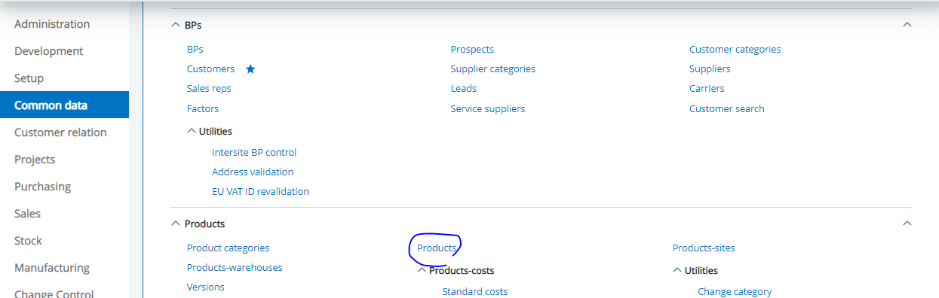

1. Click New

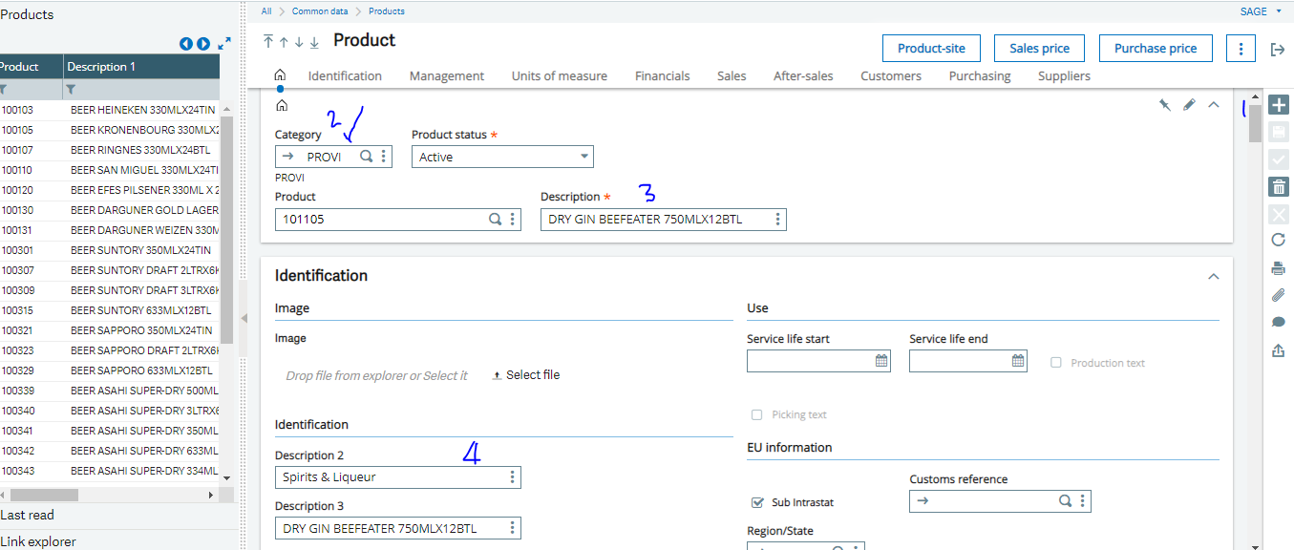

1. Select the Category
2. Enter the name of the product in the Descriptions field
3. Enter the UPC code
4. Navigate through each of the Tabs to fill in the required info
5. Click Create

That’s the end of the Process

* **How to create Supplier**

Goto-common data- BPs- Supplier

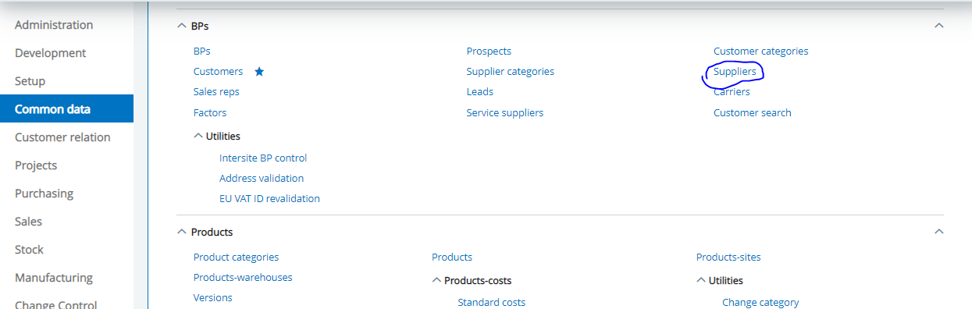

1. Click New

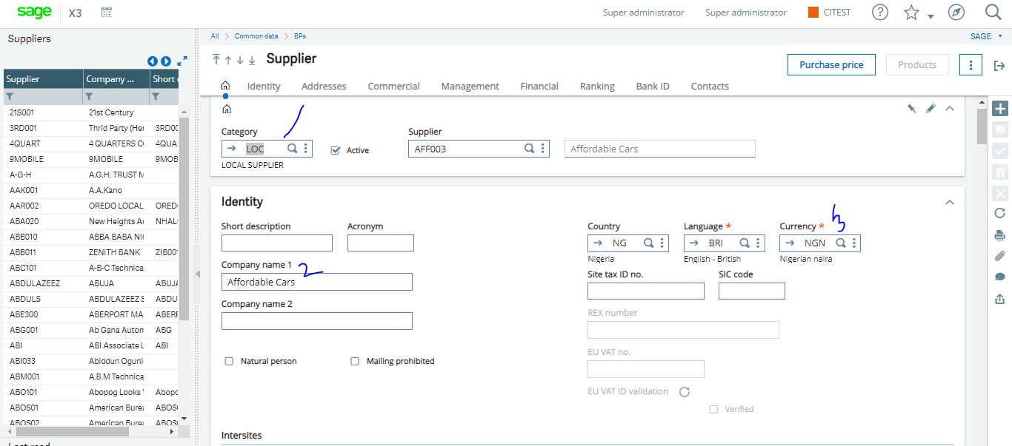

1. Select the Category
2. Enter the Supplier name in the Name 1 field
3. Tab through all the Tabs to fill required information.
4. Click create

That ends the process of creating a Supplier.