

**How to Approval a Purchase Request or Purchase Order**

**Goto – Usage – Usage –Workflow.**

**After clicking on workflow, a screen will pop out and select Purchase signatures.**

**Please find screen shot below.**

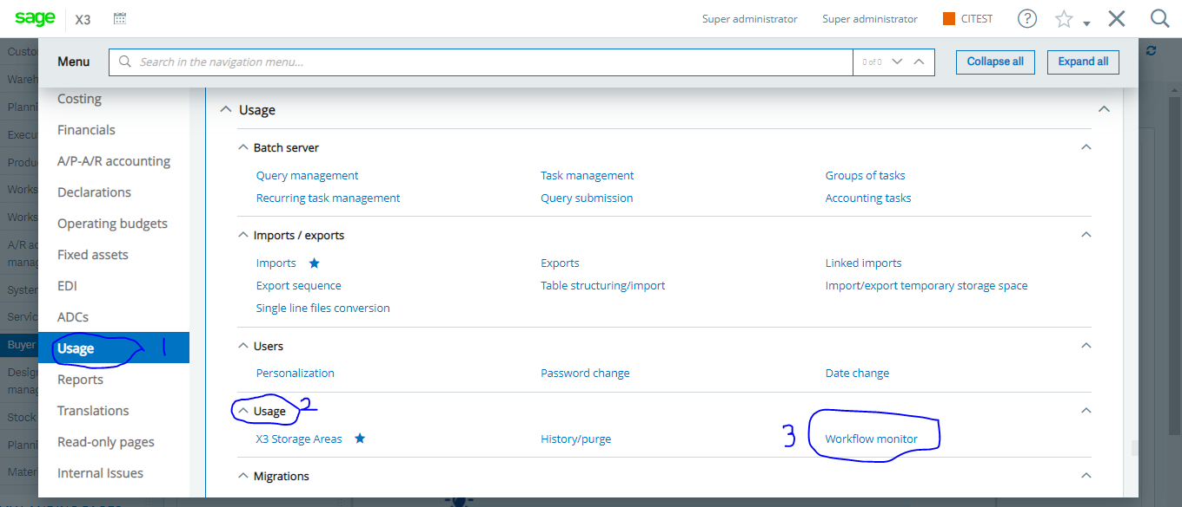



**BCL/QMS/BYS/SOP/USM/001**



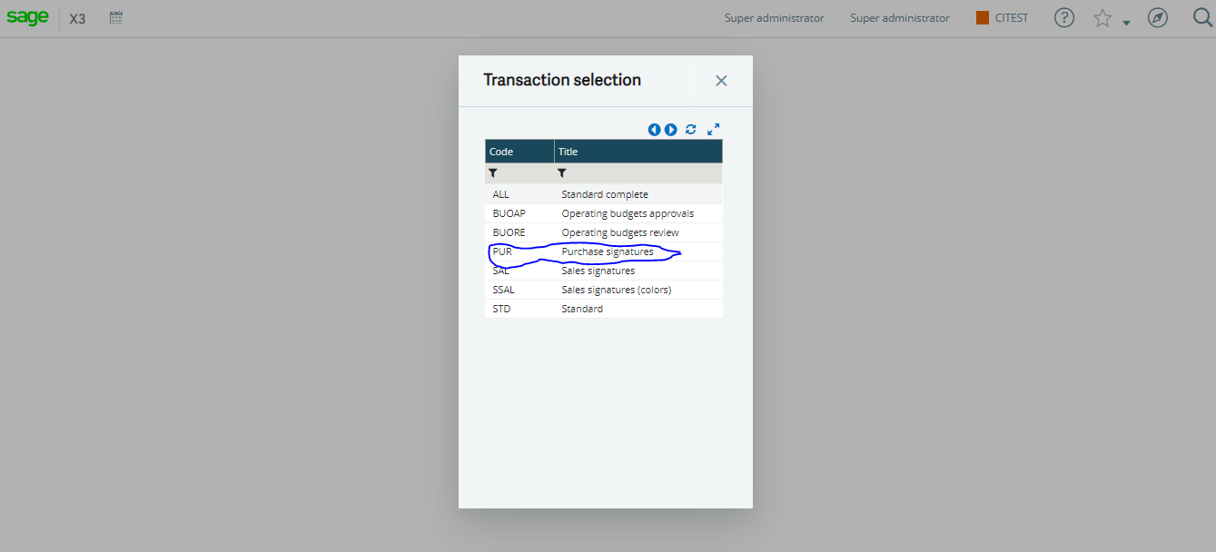

**Click on Purchase signatures, and a signature screen will pop out for you to select the transaction screen you want to approval.**

**E.g**

**PR sig – purchase request**

**Order Sig - purchase Order.**



**BCL/QMS/BYS/SOP/USM/001**



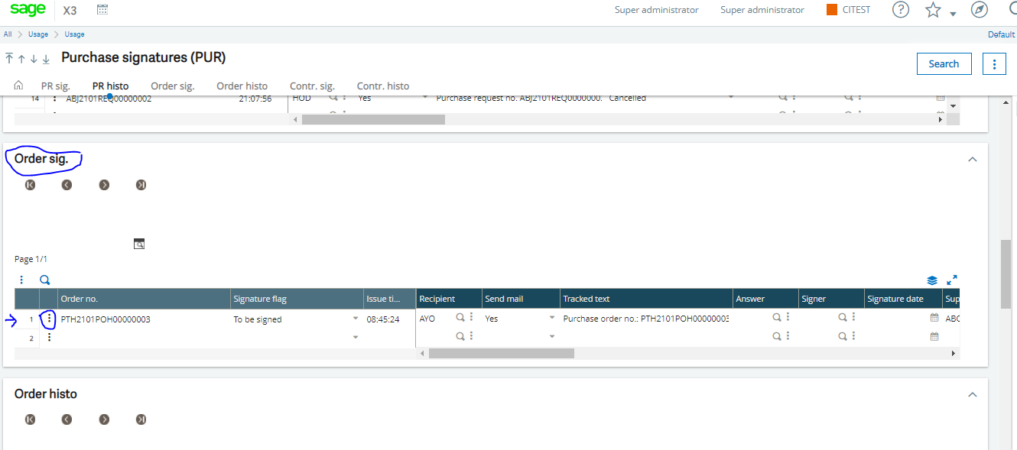

**Click on the Action box (1) and scroll down to signature.**

**Click on signature (2) and a pop screen will display for you to choose Reject or accept.(3)**



**BCL/QMS/BYS/SOP/USM/001**



**Please find screen shot below.**

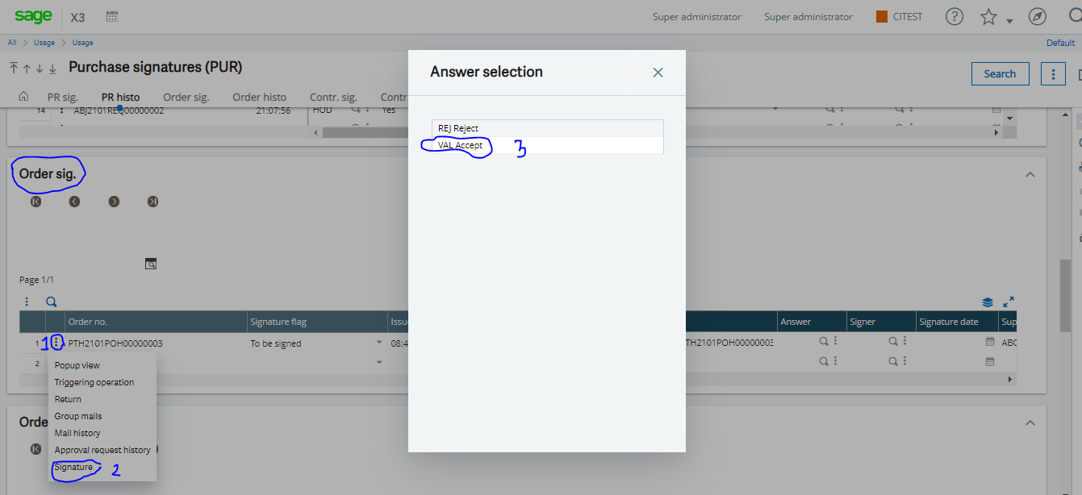



**BCL/QMS/BYS/SOP/USM/001**



**Please find screen shot below.**

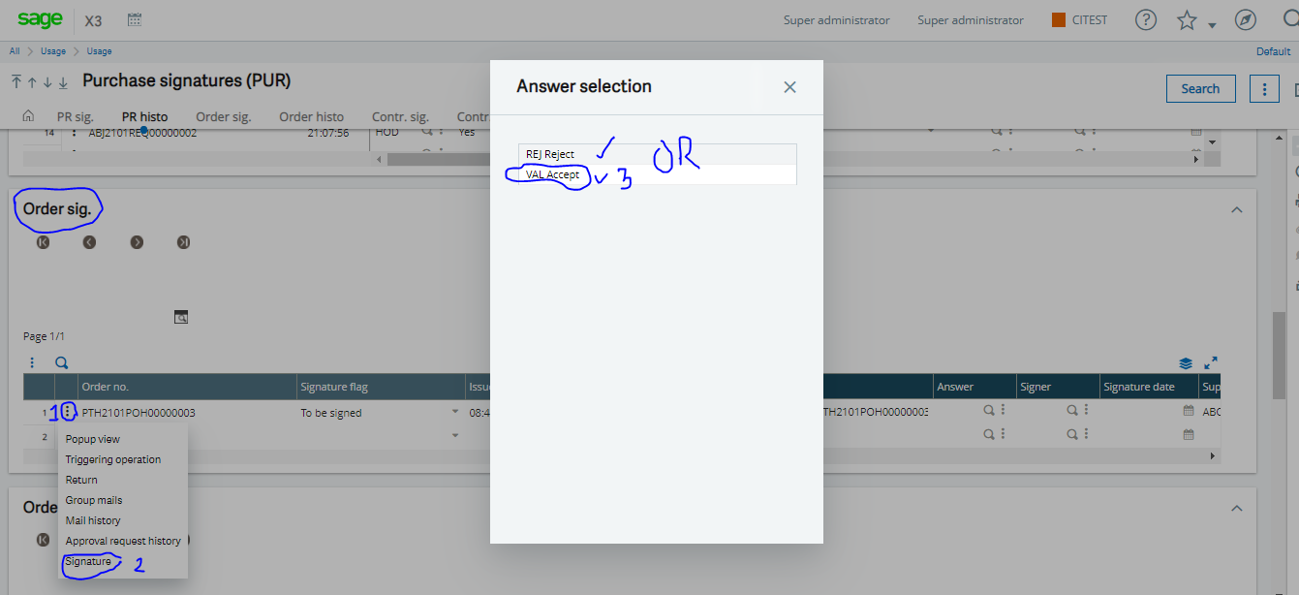



**BCL/QMS/BYS/SOP/USM/001**