**How to login to SAGE X3**

Kindly Put your username and password given to you and click signin

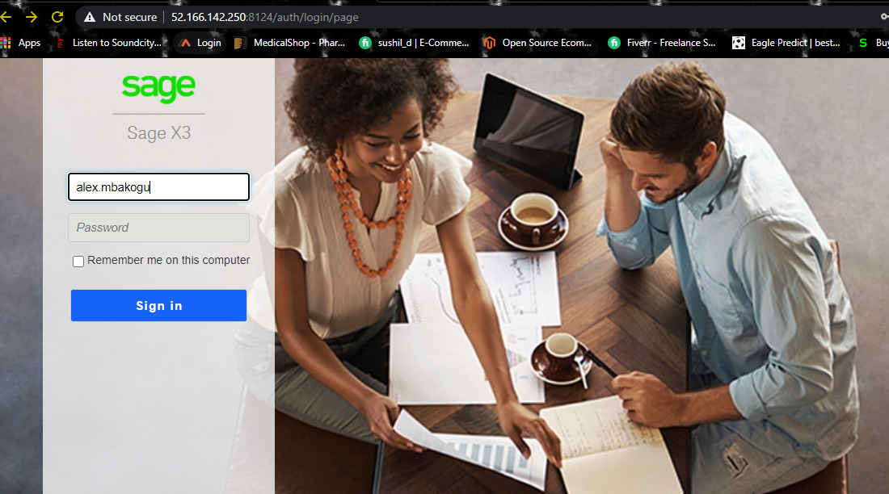

The system will prompt you to change your password.

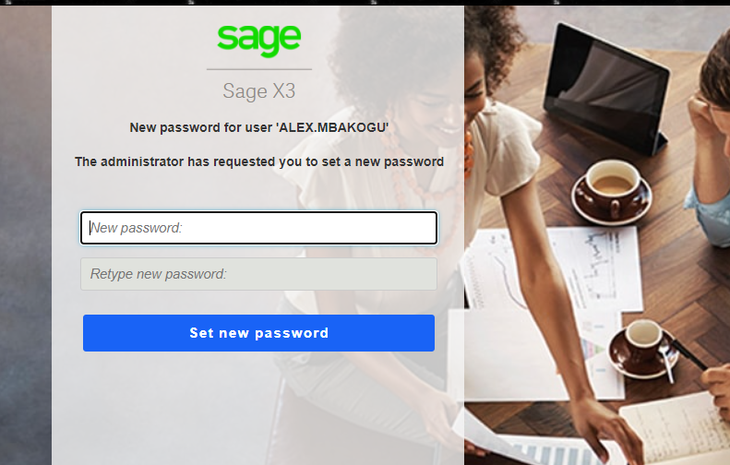

Once you are logged in , it will take you to your dashboard as shown below.

1. Is your endpoint, which mean folder either LIVE folder(CISAGE) or Test Folder(CITEST)

Live folder is where your live transaction is been done while the Test folder is where your test transaction is been done.

1. Is the open navigation menu Tab, once you click it, it will display the modules that is assigned to you.

Find sceen shot below.

